Car Maintenance and Service Booking System
Name: Lucas Oliveira
Student number:C00298828

Description
This project is a Java-based Car Maintenance and Service Booking System developed using object-oriented principles. The system allows users to manage vehicle service appointments through a graphical user interface connected to an SQLite database. The application supports CRUD operations, database relationships, input validation, and error handling.

Requirements
The system was designed to meet the following functional and technical requirements
- Allow users to create, view, update, and cancel service appointments
- Store and manage data related to car owners, vehicles, appointments, service types, and payments
- Use a relational database (GUI) using Java Swing for user interaction
- Provide a graphical user interface (GUI) using JAVA SWING for user interaction
- Display appointment information using a JTable component for clear and organised data presentation
- Use JComboBox components to allow users to select valid owners, vehicles, and service types
- Implement input validation to ensure required field(e.g. date/time) are correctly entered
- Include error handling mechanisms to manage database and user input errors gracefully
- Use SQL JOIN operations to retrieve and display related data from multiple tables in a single view
- Ensure the system follows object-oriented programming principles, including separation of concerns using DAO classes

Database Tables
Car_Owner – Stores customer details including name, email, and phone number.
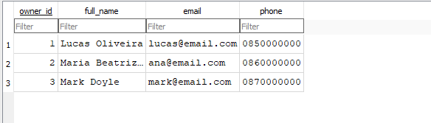

Vehicle – Stores vehicle details and links each vehicle to a car owner through a foreign key.
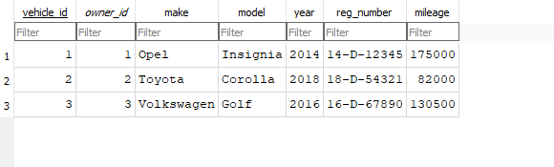
Appointment – Stores booking details such as service type, date/time, status, location, and notes.
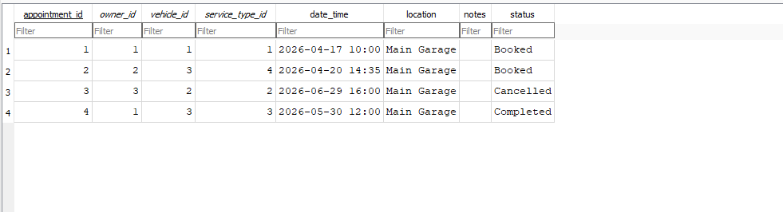
Service Type – Stores the services offered by the mechanic
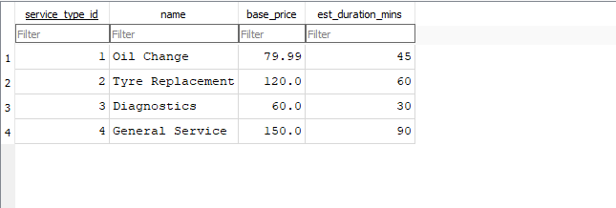

ER Diagram
The ER diagram represents the database structure of the Car Maintenance & Service Booking System. It shows the main entities used in the system, including car owners, vehicles, service types, appointments, and payments. Relationships between entities are defined using primary and foreign keys, allowing the system to maintain data consistency and support appointment booking, service tracking, and payment management.
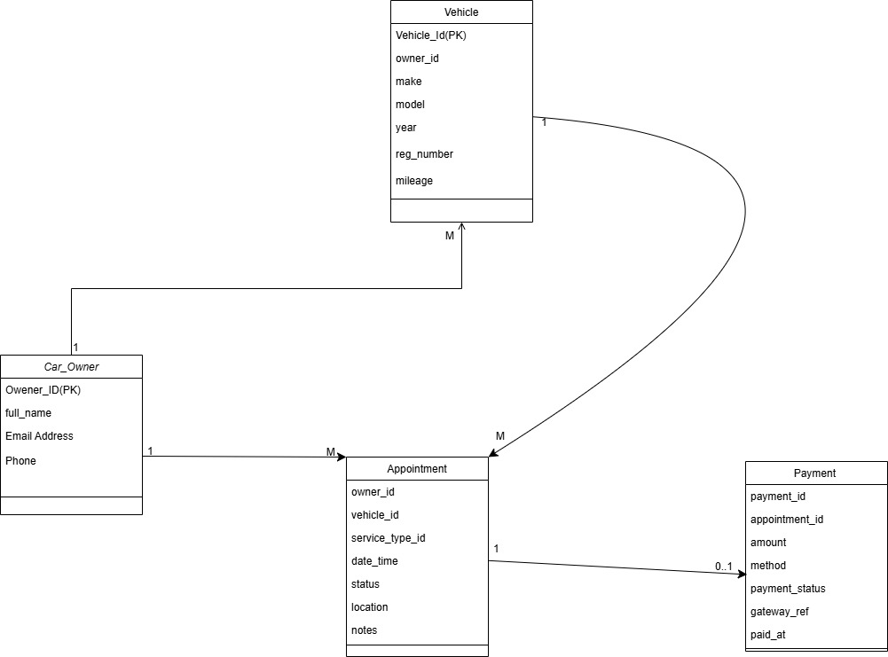

Source Code Snippets
1 – Database Connection (DBConnection.java)
1. public class DBConnection {
2.
3. private static final String DB_FILE_NAME = "car_maintenance.db";
4.
5. public static Connection getConnection() throws SQLException {
6. Path dbPath = resolveDatabasePath();
7. String sqlitePath = dbPath.toAbsolutePath().normalize().toString().replace('\\', '/');
8.
9. try {
10. Class.forName("org.sqlite.JDBC");
11. } catch (ClassNotFoundException ex) {
12. throw new SQLException("SQLite JDBC driver not found. Ensure sqlite-jdbc jar is on the runtime classpath.", ex);
13. }
14.
15. Connection conn = DriverManager.getConnection("jdbc:sqlite:" + sqlitePath);
16.
17. // SQLite does not enforce FK constraints unless explicitly enabled on each connection.
18. try (Statement st = conn.createStatement()) {
19. st.execute("PRAGMA foreign_keys = ON");
20. }
21.
22. return conn;
23.
24.
25. }
This class establishes a connection between the Java application and the SQLite database using JDBC. It centralises the database connection logic so it can be reused across the system
2. Inner Join Query(getAllAppointments)
1. // READ: Get all appointments
2. public List<AppointmentRow> getAllAppointments() throws SQLException
3. {
4.
5. String sql = """
6. SELECT
7. a.appointment_id,
8. COALESCE(o.full_name, '[Unknown Owner]') AS owner_name,
9. COALESCE(v.reg_number, '[No Reg]') AS reg_number,
10. COALESCE(v.make || ' ' || v.model, '[Unknown Vehicle]') AS vehicle,
11. COALESCE(s.name, '[Unknown Service]') AS service,
12. a.date_time,
13. a.status,
14. a.notes,
15. COALESCE(NULLIF(TRIM(p.method), ''), 'Not set') AS payment_method,
16. COALESCE(NULLIF(TRIM(p.payment_status), ''), 'Pending') AS payment_status
17. FROM appointment a
18. LEFT JOIN car_owner o ON a.owner_id = o.owner_id
19. LEFT JOIN vehicle v ON a.vehicle_id = v.vehicle_id
20. LEFT JOIN service_type s ON a.service_type_id = s.service_type_id
21. LEFT JOIN payment p ON a.appointment_id = p.appointment_id
22. ORDER BY a.date_time;
23. """;
This query combines data from multiple related tables using INNER JOIN and LEFT JOIN. It allows the system to display complete appointment details such as customer name, vehicle, service type, and payment information in a single result.
3. Create Appointment (INSERT)
1. public class TestCreateAppointment {
2. public static void main(String[]args){
3. try{
4. AppointmentDAO dao=new AppointmentDAO();
5.
6. // Create appointments with different owner IDs
7. int[] ownerIds = {1, 2, 3};
8. int[] vehicleIds = {1, 2, 3};
9.
10. for (int i = 0; i < ownerIds.length; i++) {
11. int ownerId = ownerIds[i];
12. int vehicleId = vehicleIds[i];
13. int serviceTypeId = 2;
14.
15. String dateTime = "2026-07-" + String.format("%02d", 15 + i) + " 10:30:00";
16. String location = "Main Garage";
17. String notes = "Customer need tyre replacement.";
18. String status = "Booked";
19.
20. int newId = dao.createAppointment(ownerId, vehicleId, serviceTypeId, dateTime, location, notes, status);
21. System.out.println("New appointment created with ID: " + newId);
22. }
23.
24. var list=dao.getAllAppointments();
25. System.out.println("\nAppointments found:"+list.size());
26. for (var a: list){
27. System.out.println(
28. a.appointmentId+" | "+
29. a.ownerName+" | "+
30. a.regNumber+" | "+
31. a.vehicle+" | "+
32. a.service+" | "+
33. a.dateTime+" | "+
34. a.status
35. );
36. }
37. } catch(Exception e){
38. e.printStackTrace();
39. }
40. }
41.
42. }
This method inserts a new appointment into the database using a prepared statement. Prepared statements improve security by preventing SQL injection and ensuring correct data handling.
4. Update Appointment
1. public class TestUpdateAppointment{
2. public static void main(String[] args){
3.
4. try{
5. AppointmentDAO appointmentDAO= new AppointmentDAO();
6. int appointmentID=2; // ID of the appointment to update
7.
8. boolean ok1=appointmentDAO.updateAppointmentStatus(appointmentID, "Delayed");
9. System.out.println("Appointment status updated: " + ok1);
10.
11. boolean ok2=appointmentDAO.rescheduleAppointmentDate(appointmentID, "2026-05-05");
12. System.out.println("Rescheduled: " + ok2);
13.
14. if (!ok1 && !ok2) {
15. System.out.println("No row updated. Check whether appointment_id=" + appointmentID + " exists.");
16. }
17.
18. var list=appointmentDAO.getAllAppointments();
19. for(var a:list){
20. System.out.println(a.appointmentId + " " + a.service + " " + a.dateTime + " " + a.status);
21. }
22. } catch(Exception e){
23. e.printStackTrace();
24. }
25. }
26.
27. };
This method updates the status of an appointment (e.g. Completed or rescheduled). It allows the system to modify existing records.
5. Cancel Appointment
1. public class TestDeleteAppointment {
2.
3. public static void main(String[] args){
4. try{
5. AppointmentDAO appointmentDAO=new AppointmentDAO();
6. int appointmentIDToCancel=6; // ID of the appointment to cancel
7.
8. boolean canceled=appointmentDAO.cancelAppointment(appointmentIDToCancel);
9. System.out.println("Appointment canceled: " + canceled);
10.
11. var list=appointmentDAO.getAllAppointments();
12. for( var a:list){
13. System.out.println(a.appointmentId+ " | " + a.service + " | " + a.dateTime + " | " + a.status);
14. }
15.
16. } catch (Exception e) {
17. System.err.println("Error: " + e.getMessage());
18. }
19. }
20.
21. }
This method updates the status of an appointment (e.g. Cancelled). It allows the system to modify existing records without deleting them, which helps maintain data history.
6 GUI Dialog box Create Dialog (showCreateDialog())
1. private void showCreateDialog() {
2. try {
3. JComboBox<AppointmentDAO.OwnerItem> cmbOwner = createFormComboBox();
4. JComboBox<AppointmentDAO.VehicleItem> cmbVehicle = createFormComboBox();
5. JComboBox<AppointmentDAO.ServiceTypeItem> cmbService = createFormComboBox();
6. JComboBox<String> cmbPaymentMethod = createFormComboBox();
7. cmbPaymentMethod.addItem("Card");
8. cmbPaymentMethod.addItem("Cash");
9.
10. int result = JOptionPane.showConfirmDialog(
11. this,
12. panel,
13. "Create Appointment",
14. JOptionPane.OK_CANCEL_OPTION,
15. JOptionPane.PLAIN_MESSAGE
16. );
17.
18. if (result == JOptionPane.OK_OPTION) {
19. AppointmentDAO.OwnerItem selectedOwner =
20. (AppointmentDAO.OwnerItem) cmbOwner.getSelectedItem();
21. AppointmentDAO.VehicleItem selectedVehicle =
22. (AppointmentDAO.VehicleItem) cmbVehicle.getSelectedItem();
23. AppointmentDAO.ServiceTypeItem selectedService =
24. (AppointmentDAO.ServiceTypeItem) cmbService.getSelectedItem();
25.
26.
27. int newId = dao.createAppointment(
28. selectedOwner.id,
29. selectedVehicle.id,
30. selectedService.id,
31. dateTime,
32. location,
33. notes,
34. status,
35. paymentMethod
36. );
This GUI component allows the user to create a new appointment using a dialog window. It uses Swing components such as JComboBox and JTextField to collect input and sends the data to the DAO layer for database insertion.

These code snippets highlight the key functionality of the system, including database connectivity, data retrieval using joins, data insertion, updates, and user interaction through the graphical interface.

Tests
1.1 Create Appointment
Test Case | Input | Expected Result | Actual Result
Create a new appointment | Valid Owner, vehicle, service, date/time | Appointment is inserted into database and displayed in table | Successful

1.2 Read Appointments (Display Data)
Test Case | Input | Expected Result | Actual Result
Load appointments | Click “Refresh” | JTable displays all appointments with joined data | Successful

1.3 Mark Appointments as completed
Test Case | Input | Expected Result | Actual Result
Update Status | Select Appointment -> “Mark Completed” | Status changes to “Complete” in database and GUI | Successful

1.4 Reschedule Appointments
Change date/time | Select Appointment  - Enter new date/time | Appointment date is updated in database and GUI | Successful
1.5 Cancel Appointment
Cancel appointments | Select Appointment -> Click “Cancel” | Status changes to “Cancelled” | Successful

All test cases were executed successfully, confirming that the system performs all required CRUD operations correctly and maintains data consistency between the GUI and the database.

Project API

Main Classes
- DBConnection – establishes the SQLite database connection using JDBC.
- AppointmentDAO – handles CRUD operations and JOIN queries for appointments.
- AppointmentsFrame – provides the Swing-based user interface for viewing and managing appointment data
- Main – starts the program and opens the main application window.

Key Methods
- getConnection() – returns a valid database connection.
- getAllAppointments() – retrieves joined appointment data from multiple tables.
- createAppointment(...) – inserts a new appointment record.
- updateAppointmentStatus(...) – updates the appointment status.
- rescheduleAppointmentDate(...) – changes the date and time of an appointment.
- cancelAppointment(...) – marks an appointment as cancelled.

System Interaction
The GUI interacts with the DAO layer to perform operations. User actions in the interface (such as creating or updating an appointment) trigger methods in the AppointmentDAO, which then execute SQL queries on the SQLite database. The results are returned to the GUI and displayed using Swing components such as JTable.

